Menu
Drinks:
Pot of Tea £1.50
Americano £1.20
Latte / Cappuccino £1.50
Hot Chocolate £1.50
Luxury Hot Chocolate £1.80 (with squirty cream & marshmallows)
Cans £1.00
Fruit Juice Carton £0.40 (Decaf coffee or tea, non-dairy milks and syrups available)
(Decaf coffee or tea, non-dairy milk and syrups available)
Cakes & Bakes:
Sausage Roll £1.00
Cheese Scone with butter & chutney £1.20
Fruit Scone with butter & jam £1.20
Coffee & Walnut Sponge Slice £1.50
Victoria Sponge Slice £1.50
Death By Chocolate Sponge Slice £1.50
Millionaire Shortbread £0.80
Lemon Drizzle Traybake £0.80
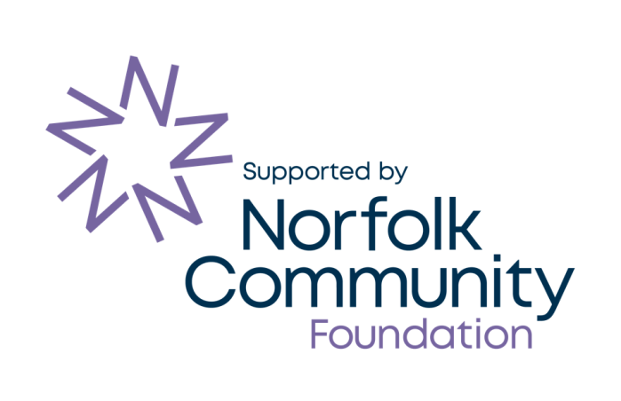
Fruity Flapjack £0.80
Rocky Road £0.80
Giant Vanilla Cookie £0.50

